Community Food Support for holidays for families with children on free school meals – Week commencing 26/10/20

West Oxfordshire Community Food network

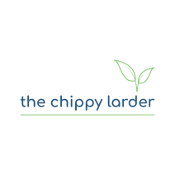 | Chippy Larder | Have sourced food for 100 families who would normally receive free school meals living in Chipping Norton and surrounding villages | Phone: 07890 394297  Email: thechippylarder@gmail.com  https://www.facebook.com/pages/category/Community-Service/The-Chippy-Larder-101325341520812/ | Chipping Norton and surrounding villages
 | Besom | Is supporting schools with referrals  Schools can contact the Besom if not already in touch  Delivery only | https://www.witneybesom.org/ | Witney and 7 mile radius
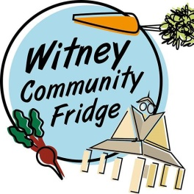 | Witney Fridge | All welcome to come and reduce food waste - Open 11am-12noon on Mon, Tues, Thurs, Sat  Some meals donated by COOK next week which are prioritised for those in need  Collect from rear of High Street Methodist Church | https://www.facebook.com/WitneyFridge/ | Witney mainly
 | Eynsham Community Larder (Eynsham food bank) | Can support anyone struggling to make ends meet in Eynsham, Cassington & Long Hanborough, on a regular or one-off basis. | Email: eynshamhelp@gmail.com  Phone: Bob Thiele on 07738 063 083. | Eynsham, Cassington and Long Hanborough
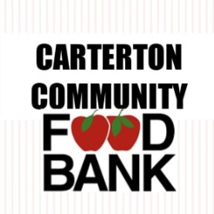 | Carterton Foodbank in conjunction with SSAFA | Ready to deliver lunch boxes to all families identifying as needing support  Are making their usual food parcels available as usual | Contact: Cllr Lynn Little or Pastor Blesson Kallimel 07790451567 or 07913662763  https://en-gb.facebook.com/Cartertoncommunityfoodbank/ | Carterton and surrounding Parishes.
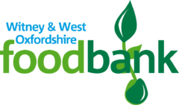 | Witney and West Oxfordshire Foodbank | Any school that is not a referrer currently, could immediately sign up and do immediate referrals for 5 day parcels | info@witney.foodbank.org.uk | Witney and West Oxfordshire
 | Cornerstone Charlbury | Is supporting Charlbury School | Contact: cornerstone@stmaryscharlbury.co.uk | Charlbury
 | North Oxfordshire Community Foodbank | Aims to provide food parcels to people living in Woodstock, Chipping Norton and Charlbury areas. | If you are in need of help vouchers for parcels can be obtained via local referral agencies including Baptist Church Ministers or contact direct for more information:  tel: 07929-721172 email: admin@northoxfordshirecommunityfoodbank.org.uk | Woodstock, Chipping Norton and Charlbury areas.
 | Carterton and Brize Norton Community Assistance | Will have 150 home cooked meals (spaghetti bolognaise, fish pie, pasta bakes etc) prepped and ready from Monday onwards, so any families that need meals for their kids are welcome to get in touch.  Provide emergency food help in general to people in Carterton and Brize Norton | Contact  https://www.facebook.com/groups/613436352552367/?ref=web_social_plugin  cartertonassistancegroup@gmail.com | Carterton and Brize Norton
 | Syrian Community  Oxford and Oxfordshire | We are still running our food distribution every Friday. Happy to deliver a food parcel to families in need. Our operation runs in Oxford then we deliver the food around the county  Available to anyone from any background | Contact WODC for details and to be put in touch  01993 861562  Response.hub@westoxon.gov.uk | Countywide

Any parents that would like help with food for their children during half term, please ring 01993704822 and ask for Billy or John, in the strictest confidence.

Emergency Assistance for Food funds
Citizens Advice West Oxfordshire can provide support for those in urgent need of food with access to food vouchers through West Oxfordshire DC’s Food and Essential Supplies scheme. They can also help with support for Electricity Top-Ups for those on a pre-payment meter: info@citizensadvicewestoxon.org.uk

NHS Healthy Start Vouchers
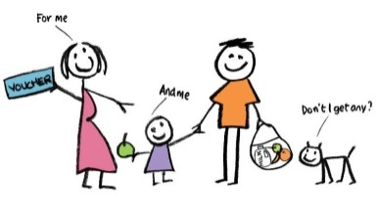
Pregnant or have children under the age of 4? You could qualify to receive free vouchers every week to spend on basic foods such as milk, fruit & vegetables, pulses, infant formula & vitamins.

Pregnant women & parents with children between the age of 1 & 4 yrs are eligible for vouchers worth £3.10 per week, or children up to age 1 £6.20 per week.

To be eligible the person must be at least 10 weeks pregnant or have a child under 4 years and be in receipt of:
- •Income Support, or
- •Income-based Jobseeker’s Allowance, or
- •Income-related Employment and Support Allowance, or
- •Child Tax Credit (with a family income of £16,190 or less per year), or
- •Universal Credit (with a family take-home pay of £408 or less per month).

You also qualify if you are under 18 and pregnant, even if you don’t get any of those benefits or tax credits.

To find out more, check if you qualify & register please click on the link below https://www.healthystart.nhs.uk/

Some businesses offering help…

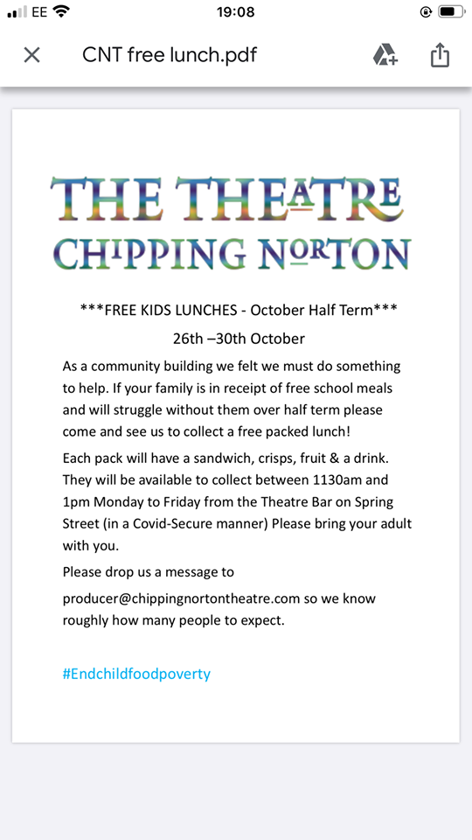
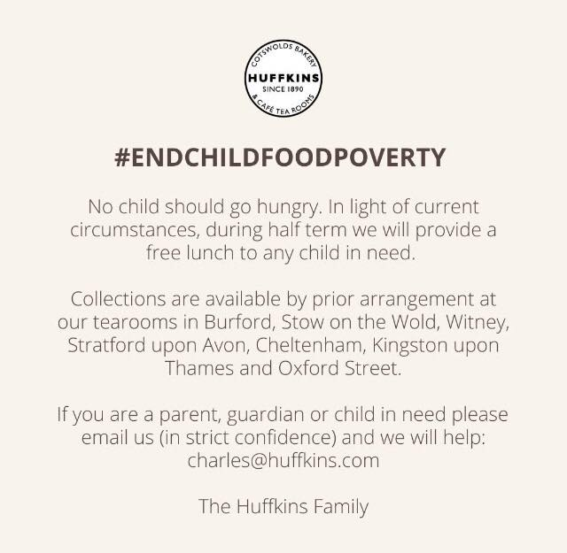

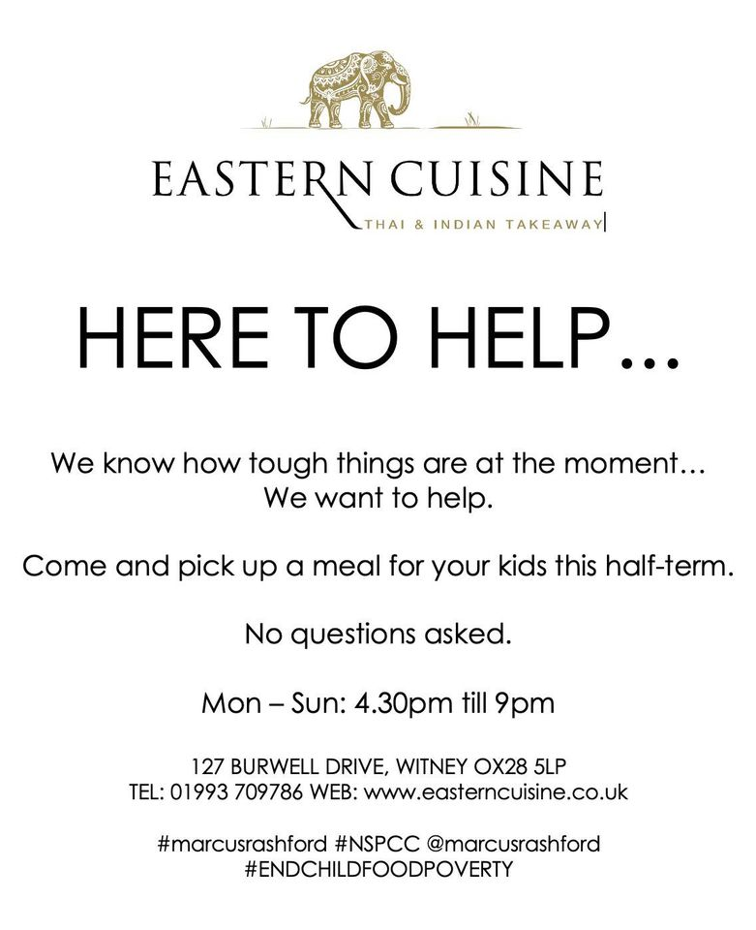
Smarts Fish and Chip Shop in Witney – get in touch in confidence if you are struggling for hot food for your children during the school holidays

If you are concerned a child will go hungry over the half term holiday please email us at
coffee@uecoffeeroasters.com.

We will be providing lunches free of charge for children in and around our community for the entire duration of the holidays.
All information is kept strictly confidential and we ask for nothing but mutual dignity and respect.

Witneymainly

