Witney Town Council Christmas Light Competition
Competition Entry Form 2021
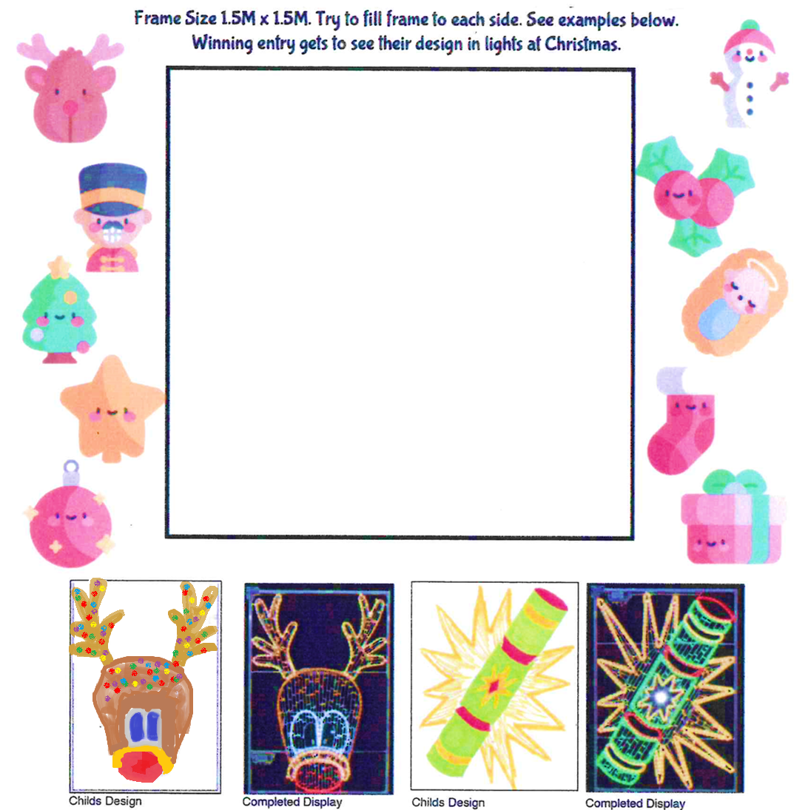

Your Name
Your Age
Your School
Competition entries must be received for judging by 4.30pm on Friday 16th July
Email your entry to: communications@witney-tc.gov.uk or post to
Christmas Light Competition,
Witney Town Council, Town Hall, Market Square, Witney, Oxon, OX28 6AG

