WITNEY LAKE AND COUNTRY PARK

MANAGEMENT PLAN

2024-2034

**Written by Carl Whitehead, Biodiversity and Green Spaces Officer**

**April 2024**

**Contents**

**Where are we now?**

* Introduction
* Management Reports and Surveys
* The Country Park Today
* Legal Compliances and Policy Context Frameworks
* Site Description

**Where do we want to get to?**

* Vision
* Assessment and analysis
  + Ecology
  + Landscape
  + Management
* Visitors and Community Needs
* Management Objectives

**How will we get there?**

* Removal and Control of Invasive Species
* Surveys

**Finance and resources.**

* Budget

**How will we know when we have arrived?**

**Monitoring and review**

**Appendices**

**Where are we now?**

**Introduction**

This management plan has been written by Carl Whitehead, Witney Town Council’s Biodiversity and Green Spaces Officer, who has responsibility for the Witney Lake and Country Park. It has been created in response both to his employment and Witney Town Council’s current Open Spaces Strategy. We also have recruited a Park Ranger to support the B&GSO. And he started on 15/04/2024

Information from previous reports and surveys has been utilised in the writing of this plan, including the previous management plan written by Adrian Shaw in 1995. The 1995 plan was actioned for the period of both Adrian’s employment and that of his successor, Nigel Boden, but the Lake and Country Park was without formal management between December 2004 and July 2022. A number of the aims and objectives in the 1995 plan have been incorporated into this updated plan. The current management plan became live from 1 April 2024. It is expected that the document will be regularly reviewed with a yearly re-evaluation of its aims and objectives to ensure that it continues to provide a working and relevant framework for the Park’s management.

The following habitats found at the Country Park are considered to be Habitats of Principal Importance (HoPI) for the conservation of biodiversity in England under Section 41 of the Natural Environment and Rural Communities (NERC) Act 2006 and are important components of the biodiversity resource of the Lower Windrush Valley:

* The Lake (a eutrophic standing body of water)
* The pond on Snipe Meadow (a freshwater pond)
* Pond on Mill Meadow (a freshwater pond)
* The broadleaved woodland fringing the Lake’s eastern bank (a wet woodland)
* The remainder of the broadleaved plantation woodlands (lowland mixed deciduous woodland)
* The River Windrush and Emma’s Dyke (water courses)
* Hedgerows on Snipe and Mill Meadows (hedgerows)

A study by the Lower Windrush Valley Project and Pond Conservation (now Freshwater Habitats Trust) in 2004 recorded 110 bird species, 80 species of invertebrates and 52 different wetland plants on the site. Over the past two years, the meadow and grassland have been managed with the aim of increasing biodiversity and work has been undertaken to commission new reports and surveys to provide updated baseline data (see detailed list below).

**Management Reports and Surveys**

1995 Management plan by Adrian Shaw

2001-2023 Water level monitoring by Smiths

2004 Lower Windrush Valley Project ecological assessment on Pit 37

2005 Windrush in Witney, Recommendations

2017 Site review by Continental

2021 Phase 1 habitat survey by Dr Frank Lucas

2023 Lake water quality assessment by Dr Mike Bowes

2023 Lake survey by Dr Robert Aquilia

2023 Ariel survey of Snipe Meadow by Smiths

2023 Bathymetric survey of Lake by Smiths

2023 Arachnid & invertebrate survey of Snipe Meadow by Lawrence Bee

2023 Arachnid & invertebrate survey of Mill Meadow by Lawrence Bee

2024 WODC Local Nature Recovery Plan

2025 Phase 1 Habitat Survey by Dr Anna Senior

**The Country Park Today**

The Country Park attracts a wide range of users including (but not limited to):

* Walkers
* Dog walkers
* Runners
* Fisherman
* Cyclists
* Photographers
* Parents/carers and children
* Geocachers
* Community groups such as Nature Now, Kids Panet, Dance of the Wild

The Country Park currently has the following amenities:

* Information and interpretation boards (those installed between 1997 and 2004 need updating/replacing) New ones were installed in July 2024
* Dog bins both general rubbish and re-cycle
* Waste bins
* A defibrillator (refurbished in January 2025)
* Life rings X5
* Benches; both seating and picnic with disabled access
* Fishing platforms (including two disabled access platforms). We aim to re-furbish several of the platforms on the swims by the end of 2027
* Quarter mile marked one mile running/walking circuit routes on STRAVA

Since Carl Whitehead was employed in July 2022, the following projects have been undertaken/completed on the Country Park:

* Bank stabilisation (ongoing) 60m so far
* Replacement dog bin installation (ongoing) X6
* Life ring installation with funding from Witney Angling Society (ongoing)
* Fence replacement and new fence installation at Avenue 2 entrance
* Planting 200 meters of native hedgerow including oak standards every 8 meters with funding from the Woodland Trust
* Hedge management (ongoing)
* Bird box building including three owl boxes built by the Witney Shed 24 bird ,
* 3 Owl and 7 Bat boxes
* A tern raft built with the support of the Witney Shed and installed
* Re-furnishment of WW2 pill box on Mill Meadow including the installation of an information panel and a stone base installed
* Installation of new safety and information noticeboards
* Creation of a one-mile marked running/walking circuit
* Installation of a new 12ft field gate and installation of a re-furbished 12ft gate
* General maintenance including paths and overhanging branches/vegetation clearance.
* Removal of 5 tonnes of Himalayan Balsam from water courses and around the Lake
* Creating a fenced area within the nature reserve to provide a safe nesting area for the Lake’s swans.
* New entrance gate at Mill Meadow
* Mill Meadow cut and collect and Flail of Snipe meadow.(Annual task)
* X12 wildlife rubbing posts & X12 look out for nature signs installed around Lake and Country Park
* Installed X2 re-cycled plastic benches and X2 recycled picnic bench on lake side
* Entered a partnership with Natural England and Freshwater Habitats Trust, Nature based Solutions program to manage parts of the Two meadows we look after to preserve and increase biodiversity (report in Appendix)
* Installed a life ring on Mill Meadow
* Seeded Mill Meadow with “Green Hay” from a local SSI to increase biodiversity
* New scrape created using Rotary Ditcher
* Install X12 rubbing Posts and “look out for nature information boards
* Remove graffiti from disabled fishing platform
* Used Wood chippings to fill wheel ruts around Country Park
* Used coir rolls and brush to prevent loss of fish from lake flooding
* Regular water tests of lake and new scraps
* Repair broken furniture around park
* Mow grass to create a planting area in new orchard
* Regular cleaning of all notice boards and signage
* Creation of a Community Orchard planting 24 fruit trees (apple, pear, damson, Plum)
* 700 m lakeside path repair
* Installation of a disabled access picnic bench and installation of Pheonix re-cycled bench
* Chestnut fencing of compound at Mill Meadow
* Attaining LNR status
* Application to become a Local Wildlife Site (LWS)
* Installing a shed at lakeside allotments for use of volunteer team and allotment users
* Creation of a wildflower area on lakeside
* Creation of a community Orchard on Snipe Meadow
* Building of a hibernaculum on Snipe Meadow
* Planning and running a corporate green awareness day for a local company
* Siting and construction of joint volunteer and allotmenteers shed
* Raising the area of flooding to minimise future events

**Legal Compliances and Policy Context Frameworks**

The management of the Lake and Country Park is subject to a number of legal provisions and statutory obligations. These include:

* Statutory Instrument 2004 No.118 Prescribed Descriptions (England) Order 2004 (established statutory crime and disorder strategies)
* The Local Government Acts 1972, 1999 (established Best Value Authorities) and 2000 (established promotion of economic, social or environmental well-being)
* The Local Government and Rating Act 1997
* The Dogs (Fouling of Land) Act 1996
* The Environmental Protection Act 1990
* The Litter Act 1983
* The Public Health Acts 1848 to 1875
* The Enclosure Act 1845

In addition, a number of local policies need to considered including:

[Witney Town Council Open Spaces Strategy](https://democracy.witney-tc.gov.uk/documents/s5852/WTC%20Open%20Spaces%20Strategy%20July%202021.pdf)

Review of Biodiversity Opportunities in the Windrush Valley:

<https://www.oxfordshire.gov.uk/sites/default/files/file/countryside/smreview_of_biodiversity_opportunities_in_the_lower_windrush_valley.pdf>

West Oxfordshire Local Plan:

<https://www.westoxon.gov.uk/media/feyjmpen/local-plan.pdf>

**Site Description**

The Lake is a flooded gravel pit (known as Pit 37) and was dug initially for use in the construction of the A40 Witney bypass in the mid-1970s. It was purchased by Witney Town Council in September 1988. Today the Lake and Country Park covers 91.5 acres (37 hectares) and comprises, the Lake (which has a depth of up to 5.1 meters and is eutrophic), a traditional hay meadow (Mill Meadow) and a wet grassland (called Snipe Meadow and originally another quarry site). The distance around the Lake measures 1.8 kilometres (approximately 1.1 mile), it has an area of approximately 83,000m2 and a volume of 277,493,000 litres. The hay meadow and the grassland are located between tributaries of the River Windrush. The southern end of the Lake is set aside as a nature reserve, with the northern end being designated for leisure activities such as fishing. The grazing land to the east and north of the park was classified as being an Environmentally Sensitive Area by Natural England following the introduction of the scheme in 1987. To the west, the Park is bordered by an area of small paddocks and allotments, behind which is the village of Ducklington. The site stands at around 80 meters above sea level.

**The Lake**

The Lake is triangular in outline and bounded to the east by the River Windrush and the west by Emma’s Dyke. Neither of these connect directly to the Lake, but they provide groundwater feeds and contribute to floodwaters in extreme conditions. The Lake is partially divided into two by a promontory supporting overhead power cables. The promontory marks the start of the nature reserve area. The entire Lake is tree lined with regular, but small, open areas allowing access for angling ‘swims’ (23) and dog walkers. The promontory is cordoned off with the shoreline to the northeast also being inaccessible.

**Mill Meadow**

Mill Meadow comprises 4.9 hectares which includes a wet area of 1.944 hectares, 0.16 hectares of which is currently fenced. The meadow is a semi-improved neutral grassland, floodplain meadow which was grazed ten years ago. There is a public footpath (No:410/15/10) which transects the meadow and connects the Country Park to Langel Common. We have also utilised a grant from Councillors

Priority Fund (£2000) to create a Dragonfly area within the meadow. We have also seeded 3ha of the meadow with “green Hay” from a local SSSI and with monitor the plant species that appear along with the Greater Burnet that was already present

This work is funded through a grant from English Nature In 2025 we discovered X7 new species growing in the meadow

**Snipe Meadow**

Snipe Meadow comprises 6.399 hectares which includes several ephemeral ponds. A footpath (No:194/3/10) crosses the eastern edge of the meadow. The main field is a semi-improved neutral grassland, largely dominated by coarse grasses including tall fescue, tufted hairgrass, Yorkshire fog, timothy, common bent, false oat-grass, cock’s-foot and hard rush covering approximately 5.93 hectares. Within this area, a small clump of approximately 0.46 hectares of tall ruderal vegetation has also been established. The remaining areas of the meadow are dominated to a varying degree by broadleaved herbs including meadowsweet, greater plantain, creeping thistle, creeping cinquefoil and red clover with a further scattering of tall ruderals including common nettle, hogweed and occasional hemlock.

In the north-west corner of the site bounded by the Windrush to one side, there is a small outlier area of approximately 0.12 hectares, which in addition to the coarse grasses listed previously, contains cleavers, broad-leaved dock, creeping buttercup and occasional spear thistles and cut-leaved cranesbill. The western edges of both the main meadow and the smaller outlier area are dominated by a five- to fifteen-meter-wide band of tall ruderal vegetation including common nettle, great willowherb and Himalayan balsam, with hogweed and occasional purple loosestrife, meadowsweet, a comfrey species and a sedge species.

Towards the centre of the meadow at NGR SP 36043 08479 is the largest of the ephemeral ponds. It is kidney-shaped and covers approximately 0.013 hectares. When it was last surveyed in July 2021, the pond was holding shallow water to a depth of approximately 20 centimetres which suggests that it may be a viable long-term reservoir for aquatic flora and fauna. Emergent species were noted as including amphibious bistort and a sweet-grass, with a fringe of silverweed, hard rush and a sedge species. We have created a 0.5 ha scrape using a rotary ditcher and will monitor the colonisation of this new feature. In 2025, we planted a Community Orchard on Snipe field

**Where do we want to get to?**

**Vision**

The vision for Park is: ‘To work with the community to create a world class, vibrant and safe country park that promotes, health and wellbeing, biodiversity, education, and is accessible to all. ‘To achieve high quality green spaces across Witney, including spaces that are nationally recognised for their quality and attractions’. The management of the Country Park contributes towards achieving this aim.

The Country Park needs to be managed over the long term in such a way as to conserve and enhance its biodiversity, whilst respecting and maintaining the amenity value of the site. Management should contribute to the delivery of the Oxfordshire Nature Recovery Network by taking account of the geographic location in the Lower Windrush Valley. The most effective way to achieve consistent long-term management will be through an integrated management plan with widespread support from stakeholders.

The meadows are the largest single components of the site. The current condition suggests that it they have had no recent management. They were dominated by dense tussocks and mats of coarse grasses and rushes, together with scattered invasive tall ruderal species including common nettle and creeping thistle. This is typical of habitat of this type once traditional management by mowing and/or grazing has ceased. It generally leads to a loss of biodiversity. It may be offset by reinstatement of appropriate management. This started in 2023

**Assessment and analysis**

**Ecology**

We need to increase the biodiversity value of the whole site and maintain any area that has a high value in that state. This will be achieved by an active work program and an annual review and, if needed a re-survey of the habitat. We will also use the biodiversity metric to calculate the Biodiversity Net Gain for our holdings to both know the “value” both financially and biologically

**Landscape**

We plan to improve the overall landscape value of the site where we can make changes to increase the biodiversity while still maintaining the character of the landscape.

**Management**

We have a 10-year plan and program of work to improve, develop and maintain the site in its best condition and fit for purpose for the future. The plan will be used as an “organic “document and will be adapted as when needed if policies, legal requirements and needs change

**Visitor and Community Needs**

There is a need to have a thorough assessment of the users of the site and tie this in with the local open spaces policy and will endeavour to keep customer satisfaction at it highest by listening to their needs and implementing them where possible. We have also conducted a Visitor survey in 2024

**Management Objectives**

The following tables detail the objectives and goals set to achieve Witney Town Council’s vision and adhere to the Open Spaces Strategy.

| **Management Objectives** |  |  |  |
| --- | --- | --- | --- |

| **ACTION** | **HOW, WHEN AND OUTCOME** | **RESOURCES** | **TIMESCALE** |
| --- | --- | --- | --- |
| **ITEMS YELLOW HIGHLIGHTED ARE WORKS COMPLETED** |  |  |  |
| Bird and bat box building and siting | 24 bird boxes have been made by the Witney Shed team and these will be sited in the appropriate areas to support and promote our diverse small bird population. They will have an entrance hole which can only be used by species smaller than Great Tits. | BGSO/Volunteers | Y1 |
| Owl box siting | The Witney Shed team have built 3 owl boxes have been installed in locations most likely to attract Barn Owls. | BGSO/Volunteers | Y1 |
| Carry out Stonewort survey using boat and grapnel or snorkelling | WTC’s aquatic specialist will be asked to undertake this survey This has been done and we still have X2 Stoneworts in the lake | BGSO/Ecologist  £1,000 | Y1To be done 12June 2024 |
| Develop and implement a management plan for the Witney Lake and Country Park | Ongoing and will be completed by April 2024  COMPLETED in March 2024 | BGSO | Y1 WITH AN ANNUAL UPDATE AND REVIEW |
| 1 mile running/walking circuit | The Lake has a 1-mile marked course for use by walkers and runners. | BGSO/Volunteers | Y1 |
| Carry out a botanical survey of Witney Lake | Unless and until evidence is obtained to the contrary, Witney Lake must continue to be protected and managed as one of the foremost Lakes for aquatic plants in the Lower Windrush Valley. A full repeat of the survey undertaken in 2004 (Pond Conservation) is a priority.  This survey has already been undertaken by  Dr Robert Aquilia (see Appendix) | Ecologist | Y-1 |
| Chestnut fencing installation | This will be constructed at the Avenue 2 access point to the Country Park using staff and volunteers  13 posts installed  Also Mill Meadow entrance to complete 2025 | BGSO/Volunteers | Y1 |
| New noticeboards and interpretation signage Ordered 19/03/2024 expected del:20/05/2024 | We have 3 access points onto the Country Park and would like to have a main sign and information board at the Avenue 2 entrance and a smaller noticeboard at the other access points (see Appendix for location map and board designs)  DELIVERED AND INSTALLED IN JULY | BGSO/Volunteers  This action has a £7,000 budget already agreed | Y1-2 |
| Provide information noticeboards about the effects of flea and tick treatments, requesting that recently treated dogs are not allowed into the water. | This is in action now | BGSO  £300 pa | Y1-2 |
| Update Fishing Society agreement  This is with Town Clerk | The original agreement was signed in 1991 and requires several updates. | BGSO/SMT | Y1-2 |
| Rubbing posts for self-guided walks as well as 12 “Watch out for nature” interpretation boards | We are looking to install approximately 12 rubbing posts and interpretation boards to create a mini safari for younger users to experience with their parents/carers  INSTALLED AND READY FOR USE | BGSO/Comms Team | Y1-2 |
| Support SSE to carry out tree work underneath power lines to maximise biodiversity. | We have a 3-year work program for SSE to manage all the trees under power lines that cross the Country Park. It has been agreed with SSE’s contractors that use will be made of the cleared wood in other habitat creation projects | SSE Contractor | Y1,4,7,10 |
| Tern raft building and siting | The building has been completed by the Witney Shed and has now been installed and we already have terns on it in 2024 | BGSO/Volunteers | Y2 |
| Nature Now and Forest School Projects  This has been renewed for 2024/25 | Witney has a strong commitment to developing the younger members of the town to have a love for the natural world they live in, and so WTC have partnered with the local “Nature First” team to offer training and experience days for both young people and the people who care for them | BGSO/Volunteers | £2,400 for X6 sessions  YEARLY |
| Creation of Scrapes on Snipe Meadow as part of Freshwater Habitat Trust (FHT) and Natural England (NE) project | Rotary Ditcher  WORK COMPLETED 2024 | Contractor | Y1 and on-going |
| Creation and planting of a Community Orchard on Snipe Meadow | B&GSO and Green spaces operative working on this at present  We have been awarded £1684.58 to create the orchard  Work was done February 2025 | BGSO & GSO | Y1-3 |
| Allow to fall or fell some trees into the Lake to provide invertebrate and fish fry habitat – trees with many small branches are preferable. | This will be a winter task | BGSO/Works Team | Y1-3 |
| Create new fishing platforms in partnership with Witney Angling Society | Chairman and B&GSO to work together on design and installation We have agreed a design and club will build one over winter period  15th March first platform built done and well accepted Designs in Appx | BSGO | Y1-3 |
| Coppice Hazel hedge on Mill Meadow | Volunteers/Corporate teams and Green Spaces Team Winter 2025 | In House | Y 1-3 |
| Create a more robust and assessable route through to Snipe Meadow by Mill Meadow underpass | Awaiting results from WODC/Wychwood Trust funding bid | WODC/WT grant | |  | | --- | | Y 1-3 | |
| Create a child friendly area at Ave 2 entrance | Use 360 digger and materials for site management ASAP, | In House GST | |  | | --- | | Y 1-3 | |
| Create “duck nesting tubes for lake | Local Engineer and BGSO to design and build, then site on lake X4-6 | BGSO and Volunteers | |  | | --- | | Y 1-3 | |
| Write a management brief for Dragonfly area | Use Phase 1 report and Green Spaces team surveys, ongoing, increase biodiversity | BGSO/Ranger | |  | | --- | | Y 1-3 | |
| Replace whips and Standards in all hedges to maintain a “solid “hedge |  |  |  |
| Replace interpretation boards at Mill and Ave 2 entrances | Funding needed |  |  |
| Remove shading trees from a short section of shore along the south side of the Lake where the edge is shallowest. This will encourage marginal vegetation to re-establish so long as access is prevented by fencing off the regenerating vegetation. Some planting can be undertaken to encourage a quicker result but should be as diverse as possible and not include Typha which tends to quickly dominate. | This will be an ongoing and the aim is to begin within Year 1.  Turfs from the ephemeral ponds can also be used | BGSO/Works Team | Y1-5 |
| Around the Lake there are several areas that are suitable for developing as wildflower  mini meadows. These would be developed using an appropriate wildflower mix and managed in the same way as the larger meadows. | Areas would need to be prepared, and an approximate seed mix chosen  Pre work carried out June 2024  Areas seeded in April 2025 | BGSO/Volunteers | Y1-8 |
| Maintain Geocache sites – the Country Park is home to several geocache sites and the Town Council supports this activity that promotes health and wellbeing | Liaise with Geocache groups to confirm locations and routes. | BGSO/Volunteers | Y1,3,5,7,9 |
| Enhance visitor experience | Conduct a visitor survey Polly has agreed to look at a survey I found and adapt it for our use  DONE: Polly and Anne have created a feedback doc and will review on an ongoing basis | BGSO/Admin Team | Y1,3,5,7,9 |
| Carry out E-DNA testing to determine what wildlife (mainly amphibians) are present in the water bodies on site to assist with habitat maintenance and development (cost per test is around £250) | Freshwater Habitats Trust (FHT) can supply  E-DNA tests We have asked for a test to be done in the new Dragonfly Pond | BGSO/Volunteers  Cost of tests | Y2 |
| Fell up to X200 weak trees along A40 bypass as part of normal management of tree stock | Mark trees in August fell sept-Feb 2026 | BGSO and AR | Y2 |
| Green Flag accreditation | Once we have a management plan in place, an application will be made for Green Flag Status for the Country Park  Applied Jan 2025. We will know July 2025  We were not successful this time but had positive feedback should we wish to re-apply | BGSO | Y2 |
| Graphic Artist Walls Projects | Several graphic artists have been given permission to use the underpass at Avenue 2 to create ad hoc artworks. Discussions have been undertaken regarding the creation of a commissioned entrance image for the Country Park | Graphic Artist  £1,500 | Y2 |
| Open/Woodland Day to include crafts, events and experiences | A decision needs to be made about the best time of year to hold the event and contact needs to be made with local groups including the Wychwood Trust to get them onboard. Once initial temperatures have been taken, a project plan and timetable will need to be put into place. | BGSO/Comms Team/Project Officer/Volunteers | Y2 AND ONGOING |
| Install a deer fence and gate on peninsular to provide a barrier to stop dogs entering this area. | Installation of a 2.4-meter galvanized fence and gate. | BGSO/Volunteers  £400-£500 | Y2-3 |
| Creation of a Volunteer Team to support the management of the Country Park This will be developed more once we have the new member of staff in post | Create a recruitment strategy and put a training programme in place. We now have a policy and risk assessments so will be pushing forward with recruitment | BGSO | Ongoing |
| Register the Lake and Country Park as a Local Nature Reserve (LNR) | Agreed at council 26th November 2024  NE are now checking the details and will come back to me in the near future  NE sent letter of support on 5th March 2025  Final paperwork sent 20 March 2025 notification to go up 2nd April 2025 Active as of April 2025 | BGSO | Y2 |
| Apply for Investors in Volunteers (IiV) accreditation | Once a Volunteer Team is in place and has undertaken a sufficient body of work this should be recognised with an application for IiV. | BGSO and Project Officer | Free to apply for  Y2-3 |
| Site designation for Country Park | Apply to Thames Valley Environmental Records Office (TVERC) and Beds, Berks and Oxon Wildlife Trust (BBOWT) to have the Country Park designated as a Local Wildlife site (LWS) and a Local Nature Reserve (LNR) DONE. The process could take up to a year, but attainment of this status will be necessary for the application of future grant funding. This will be assessed in 2024/25 | BGSO and GO | Y2-4 |
| Carry out hedgerow planting and management  There are several hedges around the  Country Park, they have had little management for several years, and we aim to lay or coppice as many as appropriate. This will not only increase the life of the hedges it will also increase the biodiversity value significantly as the hedges mature | We are looking to obtain funding to increase the number of hedgerows throughout the site. And make full use of the annual budget set by the council | BGSO/Volunteers | Y2-4 |
| Creation and siting of floating platforms. The Lake has at present just one small floating island for birds to nest on and for young fish to use as a refuge against predation from birds such as Cormorants. We would like to have within the Lake as a whole, a number of floating platforms to provide additional habitats for the flora and fauna. | These can be made by volunteers and staff | BGSO/Volunteers, | Y2-4 |
| Coppice 30% Hazel on old railway bank | Winter work and look to use the product around the Country Park | Volunteers and Green Spaces Team | Y 2-3 |
| Clear stumps from under powerlines (Winter 2025) | Restore sightlines around the Country Park | Green Spaces Team | Y 2-3 |
| Create a better path surface at Mill Meadow underpass | We will spread 2 Tonne of wood chippings while we wait to see the result of the bid that WODC are putting in to improve the “Windrush in Witney” area Ranger has made a temporary fix of chippings | Chippings GST and upgraded path Contractors | Y2 and upgraded once grant funding is achieved via Wychwood Project |
| Replace half standards on Snipe Meadow | A number of the Oaks we planted in the new hedge have not survived so we will re-plant them this winter | Volunteers and GST | Y 3-4 |
| Support local groups to make use of green environment such as local dance group | We will, through comms team promote the use of the Country Park by local community organisations | Comms team and GST | Y 2-3 |
| Create areas for groups from kids Planet to experience “natural play” | We plan to open up an area near Ave 2 entrance to allow groups such as Kids Planet Nursery to have somewhere for the pre-schoolers to play and explore the natural world | GST | Y2 |
| Buy floating planted islands anchored offshore to offer bird nesting habitat as well as rich invertebrate habitat if the roots can grow though the platform into the water below. | These can be built by staff/volunteers and with potential funding we could be more  expansive in our plans | BGSO/Works Team and contractors  £11,000(Biomatrix) | Y 2-5 |
| Reptile Hibernaculum creation | As we have Grass Snakes and a number of other amphibians present on the Country Park, we will create at selected areas, Hibernaculum’s to provide breeding and hibernating habitats to allow them to lay eggs and also overwinter on our site. These can be made with the help of the volunteer team  Park Ranger has designed a reptile survey plan to be implemented August 2025 -and X1 hibernaculum already in place | BGSO/Volunteers | Y2-4 |
| Reinstate management of the meadow by an appropriate mowing and/or grazing regime to control invasive ruderal species and enhance its biodiversity value. | We are managing the meadows by mechanical means at present, and we will also look at potential use of graziers in the future  3ha on Mill Meadow are now partly funded by Natural England (managed by FHT) | BGSO/Contractors | Y2-5 WITH AN ANNUAL REVIEW AND IMPROVEMENTS |
| Creation of Otter Holts | We plan to build an Otter Holt at two locations within the Country Park. They will be made using natural wood products collected during normal management of the site. | BGSO/Volunteers | Y2-5 |
| Running event, we are looking at the possibility of having a running event that makes use of the whole of the Country Park | Work with local running club to set a course and run the event | BGSO/Volunteers, and Local Running Club | Y3 |
| Small mammal survey of Snipe and Mill Meadow | Use Longworth traps and ask local mammal group to assist | BGSO BBOWT | Y3 |
| Social and Medical Prescribing, we have the opportunity to use our green spaces as part of a plan to improve both the mental and physical wellbeing of people that are referred to us | Contact local GP’s and support groups and offer the use of the Country Park as a venue for physical and mental therapy | BGSO and Project Officer | Discussing with Nature Now team  Y3-4 |
| Increase perimeter complexity by creating small promontories from the bank in the northeastern  side where access is not public. | These should slope gently into the water at the end to provide shallow submerged habitat for plants and emergent bank for wildfowl nesting | BGSO/Works Team and Contractors | Y3-5 |
| Create a submerged promontory or shelf.to recreate the habitat suitable for stoneworts A submerged shelf or promontory is suggested being built out from a point opposite the existing promontory. This is the easiest access point for vehicles being at the end of a concrete track and free of existing vegetation. | Gravel should be deposited to a depth of 20cms below low water. Ideally once deposited, a channel should be created to prevent access from the shore. If stonewort’s are still present,  they should colonise quickly from dispersing oospores We are also looking at other areas of the Lake to site this habitat  THIS AREA HAS BEEN IDENTIFIED | Biodiversity and Green Spaces Officer (BGSO) | Y3-5 |
| Car Parking Requirements the Country Park suffers greatly from a lack of car parking locations and as an ongoing process | we will be looking to facilitate partnerships with WODC, local businesses and even potentially purchasing/leasing land to create our own car park.  We are still looking at options for this and it is included in WODC IDF plan | BGSO/WTC | Y3-6 |
| Installation, repair and replacement of Gates/Styles We have over a dozen both metal and wooden gates around and at the entrances to the country park. It has been several years since the they have been either serviced, repaired, or replaced if needed. This work is of high priority to provide security and access to areas within the Country Park | We have an ongoing repair and maintenance program for all our gates | BGSO/Volunteers  Gate-4ft =£82:00  Gate 10ft = £145:00 | AS NEEDED |
| Path repair/Maintenance We have many paths within the park, and they include grass and ballast pathways. | To maintain the grass paths a structured mowing regime is needed and the Ballast pathway around the Lake needs consistent annual maintenance, as I want to try and maintain this as a DDA access for all compliant pathways.  Working with OCC ROW Officers to agree a way forward Feb  2025 EA agreed non permit repair of flood area and filled potholes along 700m of footpath | BGSO/Volunteers and works team | AS NEEDED |
| Hedgelaying around the Country Park | We have 150 metres of laid hedge within the Country Park, and this was planted in 2014, there are also a few gaps within this hedgerow, and we will be filling those gaps to create a continuous green corridor along the Lake pathway. We also have 200m of new hedge planted by volunteers on Snipe Meadow we are also looking at other areas which through potential funding we could create more hedgerows. | BGSO/Volunteers | £4;00 per metre for rows and infill  AS NEEDED |
| Public Outreach | Maintain an active social media Prescence and update pages on a regular basis | BGSO/Publicity Officer | As Needed |
| Obtaining Grant Funding  FHT grant application agreed £9,405.60 for 10 years of management of Snipe and Mill Meadows  £2000:00 from Councillor Fund  2/3 total cost of £1428 for hedgerow products paid for by Woodland Trust  £1684.58 for orchard creation  £1600 from WODC to create a Community Orchard on Snipe Meadow | There are several environmental grant funders that we can apply to for support with identified projects within the country park and working with the project officer we will optimise these opportunities. | BGSO and Project Officer | ONGOING |
| Corporate Volunteering and support | We are planning to invite local businesses to both supports financially and through staff involvement the development and management of the Country Park  First Corporate volunteer day on 28th March 2025 | BGSO/ Admin Team | ONGOING |
| Bank Stabilisation Program | We have carried out 60m of bank stabilisation and will do another 60 m soon and then assess the need to do more once a Biodiversity Action Plan is drawn up | BGSO/Volunteers Ongoing funding is in place to carry out annual work around the Lake | ONGOING |
| Academic projects | We have a link with Oxford Brookes Collage and the team carrying out the Environmental Consultancy module of their degree. We have provided several projects which are reviewed each year for the students to choose from | BGSO | YEARLY |
| We want to start a programme of talks from local experts on several environmental subjects such as, birds bats moths etc: | There are several local speakers who will willingly carry out talks for both a younger and older audience | BGSO/Volunteers and Local Experts | YEARLY |
| Review of Biodiversity Opportunities in the Lower Windrush Valley, Conservation Enhancements for Other Habitats and Features, LWVP (2020) suggests a number of ways that the biodiversity of the Lake and Country Park might be increased. | Measures to enhance the river corridors for water voles and otters. | BGSO/Works Team  1.5K | ANNUAL |
| Review of Biodiversity Opportunities in the Lower Windrush Valley, Conservation Enhancements for Other Habitats and Features, LWVP (2020) suggests a number of ways that the biodiversity of the Lake and Country Park might be increased. | Pollarding of willows along the river corridors to reduce shading and encourage bankside vegetation. | BGSO/Works Team | ANNUAL |
| Installation of bird and bat boxes into the young woodland areas to create nesting and roosting sites where few currently exist. | BGSO/Volunteers  £300-£500pa | Y1-2 |
| Planting of new species-rich hedgerow(s) | BGSO/Volunteers  Grant Funding | Y2-10 |
| Boat Work | We have a ridged boat with an outboard motor that can be used for surveys and management of the Lake | BGSO/Volunteers | ANNUAL |
|  |  |  |  |

**How will we get there?**

**Removal and Control of Invasive Species**

Schedule 9 Species (including invasive non-native and licensed release only species) Overview Section 14 of the Wildlife and Countryside Act 1981 (‘the Act’) seeks to prevent the release into the wild of certain plants and animals which may cause ecological, environmental, or socio-economic harm. To achieve this, it makes it an offence inter alia to plant or otherwise cause to grow in the wild in Great Britain any species of plant listed in Schedule 9 to the Act.

**Himalayan balsam** is widespread across the site and in the wider Lower Windrush Valley Project area, on the fringes of the watercourses and in areas dominated by tall ruderal vegetation. At present there is no agreed best course of action to eradicate it, and any local attempt to eradicate it at Witney Lake and Country Park is certain to fail because of the prevalence of the species in the wider landscape. If a landscape-scale initiative to eradicate this species is initiated, then local measures should be taken to support the initiative. Meanwhile contractors operating on the site should be required to observe biosecurity measures to prevent the spread of Himalayan balsam from the site, notably the effective cleaning of equipment and clothing to prevent seeds or fragments of the plant being transferred to other sites.

**Nuttall’s pondweed** appears to be well established in Witney Lake having been recorded in the present survey and previously in the Pond Conservation (2005) survey. As with Himalayan balsam it is likely that this species is prevalent across the Lower Windrush Valley Project area and any local attempt to eradicate it is likely to fail. If a landscape-scale initiative is initiated then local measures should be taken to support it, and in the interim, contractors operating on the site should be required to observe biosecurity measures to prevent it’s spread through the effective cleaning of equipment and clothing.

The presence of **Chalara ash dieback** in trees around Witney Lake and Country Park Nature Reserve requires further investigation and monitoring to ensure that dead or dying trees do not become a danger to visitors. Forest Research advise that ‘With the exceptions of felling for public safety or timber production, we advise a general presumption against felling living ash trees, whether infected or not. This is because there is good evidence that a small proportion will be able to tolerate H. Fraxinus infection. There is also the possibility that a proportion of ash trees can become diseased but then recover to good health. These, too, would be valuable for our research, although it is still too early to know whether there are such trees in the British ash population’. For further information see

**Ragwort** is a native species of the British Isles. It is a specified weed under the Weeds Act 1959. It contains toxins which can have debilitating or fatal consequences, if eaten by horses and other grazing animals. Ragwort is less likely to be rejected by stock if dried and contamination of forage (hay, haylage and silage) is a particular problem. Humans may be at risk from ragwort poisoning through direct contact (eg, hand pulling) or the consumption of contaminated food. We have mainly the Oxford Ragwort on our sites.

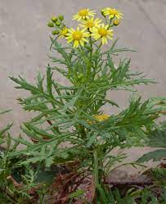Oxford ragwort (pictured left) is easily distinguished from common ragwort when in flower because it has loose, spreading flower heads, while common ragwort's flowers are densely packed in tight umbel-like corymbs. The leaves of common ragwort are usually darker and more glossy and tough than those of Oxford Ragwort.

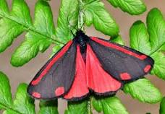

Ragwort also has a very positive side for biodiversity in that it is the larval food

source for the Cinnabar Moth (pictured right).

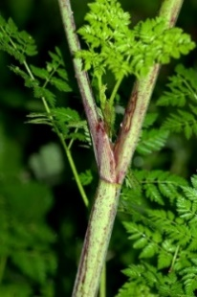

**Giant hogweed** (Heracleum mantegazzianum) is a plant in the Apiaceae family (previously known as the Umbelliferae). This family includes some well-known plants such as parsley, carrot, parsnip, cumin and coriander.

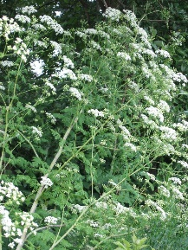**Poison hemlock**, *Conium maculatum*, is a member of the plant family Apiaceae, which contains a few important vegetable crops such as carrots, celery, and parsnip, and herbs such as parsley, cilantro, chervil, fennel, anise, dill, and caraway. It is a tall, invasive, highly poisonous weed that is sometimes mistaken for one of its crop relatives.

**Signal crayfish** is an invasive aquatic species, are present throughout mainland UK and have severe negative effects on other aquatic biota. While no effective mechanism for their eradication exists, control attempts often make use of removal by trapping. We had a company that delt with the removal and disposal of Crayfish but due to EU law this is now not possible.

**Identifying types of Crayfish**

**Native (European) White-clawed crayfish**

**Length:** Adults usually less than 10 cm (excluding claws) but can be up 12 cm.

**Body:** Usually brown or olive brown in colour. Smooth but pitted. Two pairs of ridges behind eye sockets; however, second pair may or may not be visible. Has row of sharp spines behind sides of cervical groove. Rostrum (extending point on top of head) triangular with very short aрех.

**Claws:** Top side rough, underside dirty white to pink.

**Habits/habitats:** Relatively docile. Lives in streams, rivers, canals, reservoirs, water-filled quarries. Capable of burrowing.

**Distribution:** Found central/northern England and eastern Wales.

**Non-native (North American) Signal crayfish**

**Length:** Adults usually about 15 cm, but can be up to 30 cm.

**Body:** Generally bluish-brown to reddish brown. Smooth all over. Two pairs of ridges behind eye sockets. Spines absent from behind cervical groove. Rostrum well developed with parallel sides and with long apex.

**Claws:** Smooth on both sides, underside bright red in colour.

**Habits/habitats:** Aggressive. Invasive. Lives in streams, rivers, canals, reservoirs, water-filled gravel pits. Burrows extensively. **Distribution:** Found across England, especially in the south, and Wales (also present in Scotland).

**Mink Monitoring and control**: As part of BBOWT’s recent Chimney Meadows Wetland Restoration Project, they received some funding towards mink monitoring and control within the upper River Thames catchment, and this includes the River Windrush. The funding has enabled them to buy mink rafts, traps and remote trap monitoring units ([Remoti](http://www.remotisystems.com/devices/)), and they are looking for suitable locations to deploy them. We were asked if we would be willing to host a mink raft and ideally check them in monitoring mode (or even better - trapping mode), then they can provide WTC with the rafts, traps and Remoti units.

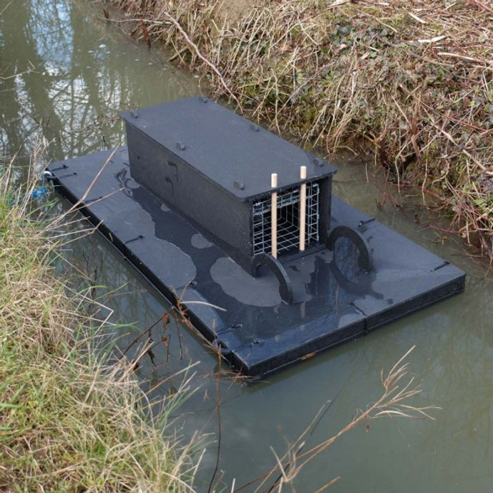

**Biological Surveys**

A number of Surveys have taken place to provide a baseline set of data to support and guide the development of the management of the Country Park. These are:

* Phase 1 survey’s covering the whole of the Country Park (see appx)
* Witney Lake and Emma’s Dike water test
* Survey of Lake Aquatic Flora and fauna (see Appendix)
* Entomological survey of Snipe and Mill Meadow (see Appendix)

**Wet Meadow management note**

Some wet grasslands have been traditionally managed as floodplain or water meadows, and in these areas hay meadow management should be continued. Ditches and other water features are incredibly important for plants, invertebrates and amphibians and should be managed sensitively and protected from agricultural runoff. Water level management is important, in particular the maintenance of a high-water table in spring and summer, and management of winter flooding.

The Country Park comprises two meadows of differing characters, one (Snipe) is a meadow created after aggregate removal so has a “cap” of soil and therefore will lack true diversity of flora and fauna, but we will manage this in the appropriate way to maximise the potential going forward.

The other meadow (Mill)is a natural floodplain meadow and has benefited from grazing in the past. It will also have the potential for a seedbank that with correct management could be released and developed.

**Finance and Resources**

**Budget**

A budget has been agreed with the responsible Finance Officer and Head of Operations to enable all Year 1 projects set out within the Management Plan to be completed. A schedule of expenditure has been proposed for the next ten years. A number of projects within that ten years will require capital funding, but it is hoped that some of this will be secured externally via grant applications and sponsorship.

**How will we know when we have arrived?**

It will be necessary for detailed key performance indicators (KPIs) to be agreed by Counsellors.

However, the following are suggestions of measures of the success of the management plan:

* The attainment of LWS status for the Country Park
* Achieving IiV status
* Being awarded Green Flag status
* Achieving a Gold award from Britain in Bloom
* Positive user feedback
* Meeting the legal criteria set out in local, regional and national green space strategies
* Delivering to budget

**Monitoring and Review**

The Management Plan will be a live dynamic document. It will be monitored and reviewed as set out below and any changes required will be actioned quickly and proactively in consultation with the relevant stakeholders.

* Weekly monitoring by the BGSO to inform schedule of work
* Quarterly overview carried out by the BGSO, Head of Operations and relevant stakeholders to ensure timeframes and budgets are met.
* Annual review by BGSO and all relevant stakeholders to ensure the plan continues to be relevant and to deliver its stated aims.

**Appendices**

***[Paper copies of these documents will be attached to the final Management Plan]***

1. Snipe and Mill Meadow management brief
2. Tenancy Agreement of Fishing Rights on the Lake at Witney Oxfordshire (being update and with Town Clerk at present)
3. Open Water Policy
4. Metal Detecting Policy
5. Tree Policy (awaiting agreement)
6. Volunteer Policy (awaiting agreement)
7. Phase 1 survey, Dr Frank Lucas (2021)
8. Phase 1 survey Dr Anna Senior (2025)
9. Entomological survey of Snipe and Mill Meadow Lawrence Bee 2023
10. Survey of Lake Aquatic Flora and fauna (Robert Aquilia 2023)
11. Breeding bird survey, 2023 James Curren (local Volunteer)
12. Budget: Current year’s budget enclosed



<https://www.witney-tc.gov.uk/wp-content/uploads/2019/07/Climate-emergency.pptx>

Witney climate emergency presentation

Mill Meadow and Snipe Meadow

Floodplain grassland and wetland management plan 2025-2035

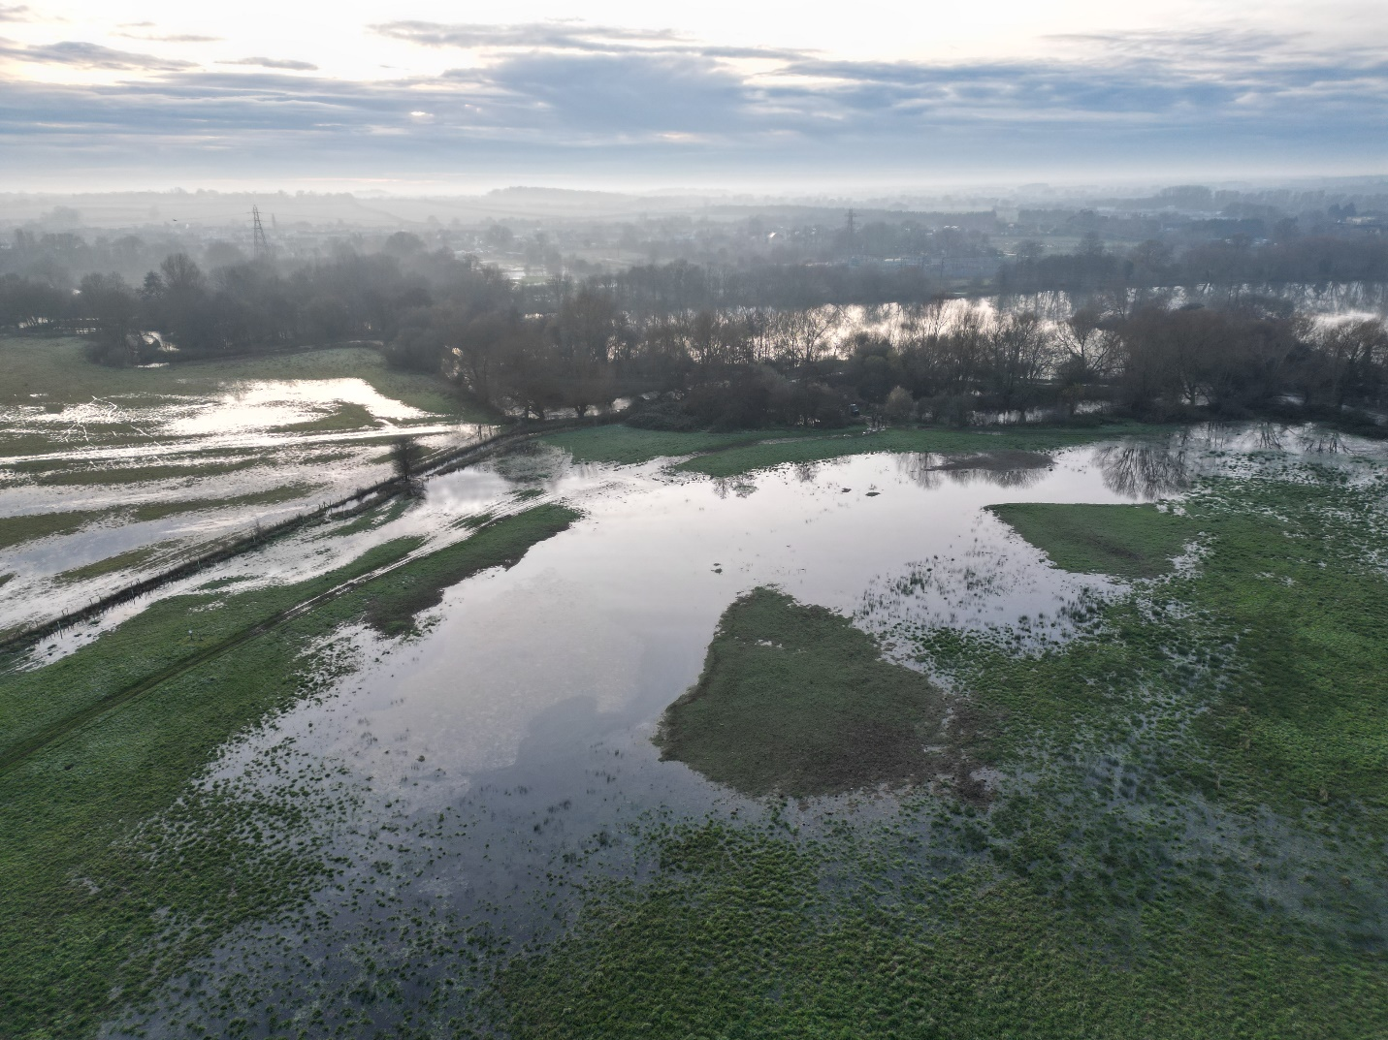

**© Freshwater Habitats Trust**

**Oxford**

**2024**

|  |
| --- |
| **For further information please contact:**  Freshwater Habitats Trust  Bury Knowle House  North Place  Headington  Oxford, OX3 9HY |

|  |
| --- |
| **Acknowledgements**  We would like to thank DEFRA and Natural England for funding the production of this Management Plan through the Nature Returns project. |

**Contents**

**1** **Overview of the plan**

**2** **Importance of floodplain habitat**

**3** **Management aims**

**4** **Management measures**

**5** **Habitat management outcomes**

1. **Overview of the plan**

**Management plan purpose**

This document details the future management and monitoring plans for the floodplain grassland restoration carried out at Mill Meadow and floodplain wetland mosaic creation carried out at Snipe Meadow, Witney, as part of the Nature Returns project in 2024-25. The provision and use of this management plan is required by Natural England as part of the signed agreement under the Nature Returns project.

**Management plan area and period**

The area of habitat covered by this plan is shown in Figure 1. The area consists of the grassland restoration area (3 ha to be managed) and the floodplain wetland mosaics (0.1 ha to be managed).

This management plan covers the ten-year period from January 2025 – January 2035, and will be reviewed by Freshwater Habitats Trust and the landowner and as required.

**Roles and responsibilities**

**Landowner (Witney Council):** to agree, review, and implement the management and monitoring plan for the grassland restoration and wetland creation areas at Witney.

**Freshwater Habitats Trust:** to provide, agree, and review the management and monitoring plan for the grassland restoration and wetland creation areas at Witney.

**Importance of floodplain habitat**

The creation and restoration of floodplain habitat in Witney was carried out to bring benefit to freshwater and other biodiversity on the site. This new habitat will also provide other ecosystem services and enhance natural capital locally.

Floodplain grasslands and wetlands provide:

**High biodiversity value** – Floodplain habitats such as wetland and floodplain grassland can be very biodiverse. Wetlands provide habitat and refuge for freshwater and terrestrial species, such as Lapwing, Water Vole and Otter. Floodplain grasslands host a suite of plants and support pollinating insects.

**Clean water** – In landscapes dominated by intensive agricultural use, wetland habitats provide a refuge of clean water. These wetlands are designed and created so that they are not directly connected to the watercourses, except when flooded, minimising the input of pollutants into the wetlands.

**Ecosystem services** – Created and restored floodplain habitats provide a multitude of ecosystem services. These include increased flood storage, carbon sequestration and storage, and amenity value.

**Management aims**

The management measures set out in this plan aim to:

1. **Maximise the benefits for freshwater biodiversity of the created and restored habitat.** Continued management is critical to realising the potential biodiversity value of the created and restored floodplain habitats at Snipe Meadow and Mill Meadow.
2. **Protect clean water at the site.** The wetlands have been designed to provide clean water within a wider landscape of agricultural improvement and water pollution, e.g. by not being directly connected to the river. Management must protect this clean water resource.
3. **Provide a site for monitoring.** Continued monitoring of the habitats is important for understanding outcomes of creation and restoration work and management activities.
4. **Promote suitable habitat for potential rare plant translocations.** Correct and continued management of created and restored habitat will provide opportunities for future rare plant translocations.

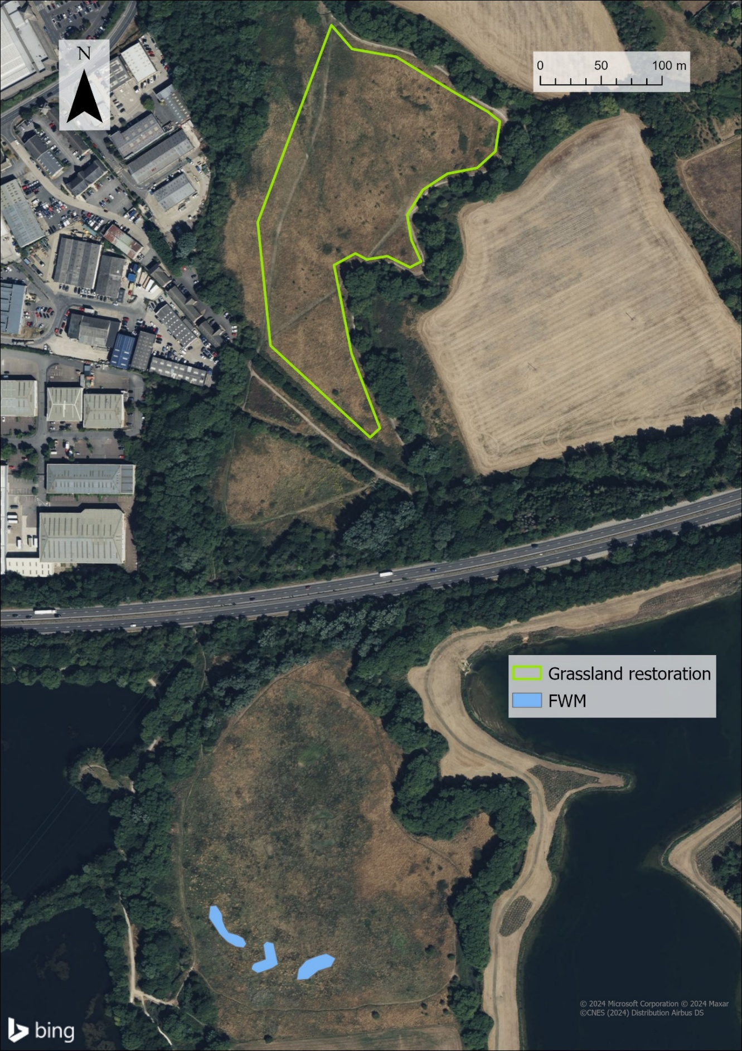

**Mill meadow (north) and Snipe Meadow (south), showing the grassland restoration and floodplain wetland mosaic areas. Areas shown for information only and can be subject to changes.**

**Management measures**

Working towards the aims listed above, the management regime for the floodplain grassland and the wetland mosaic can be found below.

Table 4 (page 9) contains an overview of the management measures for each area, including a brief description of its objectives, frequencies at which interventions should be carried out, responsible party, and details of any review timings.

Further information on the desired outcomes of management in each habitat area can be found in section 0.

**Floodplain grassland management**

To achieve the desired outcomes for floodplain grasslands, the correct management, as well as the timings of this management is extremely important.

In a nutshell, the management prescribed is that of a traditional hay meadow, with an annual cycle of late hay cut and aftermath grazing/cut and collect. Special attention must be given to preserve the preexisting populations of Great Burnet (*Sanguisorba officinalis*).

**Option 1 – No grazing**

**Table 1.** Year of green hay application.

|  |  |  |
| --- | --- | --- |
| Months | Process | Notes |
| July 2024 | Green hay spread mid-July. | Sward takes 6-8 weeks to grow up. |
| August- October 2024  (6-8 weeks after green hay spreading) | Cut and collect or regularly flail top (set at 10-15cm) to keep grasses short. | Don’t let sward grow too tall before cutting/grazing as this will create mulch and suppress seedlings.  Removing cut vegetation is important. |
| Late autumn/winter | Leave meadow uncut unless growth is vigorous | Vigorous = growth above ankle height in winter.  Avoid using heavy machinery on wet ground. |
| February/March 2025 | Cut and collect or regular flailing before April. | Helps remove early growth that would smother wildflowers. |
| April – July 2025 | Leave meadow to grow and flower |  |
| Mid July - September 2025 | Cut and collect once most plants have seeded | Removes mass which helps remove nutrients and stop smothering/overgrowth. |

**Table 2.** Subsequent years.

|  |  |  |
| --- | --- | --- |
| Months | Process | Notes |
| Mid July- September | Cut and collect once most plants have seeded. Or regularly flail top (set at 10-15cm) to keep grasses short. | Removes mass which helps remove nutrients and stop smothering/overgrowth.  Removing cut vegetation is important. |
| Late autumn/winter | Leave meadow uncut unless growth is vigorous | Allow spring flowers to bloom.  Vigorous = growth above ankle height in winter. |
| February/March | Cut and collect or regular flailing before April. | Helps remove early growth that would smother wildflowers. Do this before early wildflower growth. |
| April - July | Leave meadow to grow and flower |  |

**Cut and collect notes:**

Hay cut around mid-July or early August. The timing of the cut is key for promoting species-rich vegetation and a high proportion of wildflowers and grasses need to be allowed to set seed before the hay is cut. The exact timing will depend on weather and wildflowers present. Some years the wildflower seeds are ready early than others. You can also:

Alternate between earlier cuts (early-July) and later (August to September) can help variety of plants bloom. Or cut part of the meadow in July and the rest in later months.

If possible, spread cuttings out to dry and turn once a day. This can also encourage seeds to drop off and set in the soil. Bale the hay after 3-5 days and remove.

Unmown strips can be left along edges for pollinators.

Intensive cutting can affect bird, mammal and invertebrate populations, so care needs to be taken to minimise any potential damage. Best practice includes:

Consider staggered cutting patterns (rather than cut it all in one day, cut sections over a few weeks). This will help by giving ground-dwelling species time to escape, finish their breeding cycle and access foraging habitat for longer.

If feasible, mowing from the inside out and towards unmown areas is good practice to minimise casualties of animals present on site.

**Option 2 – Grazing**

**Table 3.** If grazing was introduced, follow the below regime.

| Months | Process | Notes |
| --- | --- | --- |
| July-August | Hay cut and collect between mid-July and mid-August (exact timing depends on weather). | Removes mass which helps remove nutrients and stop smothering/overgrowth.  Removing cut vegetation is important. |
| August - November | Aftermath grazing of new grass growth a few weeks after cut. Cattle preferable. | Aim to reduce sward to 2-5cm before end of winter.  Avoid poaching.    Breaks up vegetation, push seeds into soil, and eat down grass before wetter weather follows. |
| Autumn/winter **wet** weather | Remove livestock to avoid poaching and compaction. |  |
| Winter/early spring **mild and dry** | Light grazing until March/April. Aim for 2-5cm sward height. | Helps remove early growth that would smother wildflowers.  Yellow rattle starts germinating in April so definitely no cattle by then. |
| April-July | Shut the meadow to livestock and mowing. Let the wildflowers bloom. |  |

Stocking densities:

Aftermath grazing (August – November):

Levels of grazing vary for each type of grassland and is estimated at 1-2.25 [Livestock Units](https://www.gov.uk/government/publications/countryside-stewardship-cs-mid-tier-and-wildlife-offers-manual-for-agreements-starting-on-1-january-2023/annex-6c-convert-livestock-numbers-into-livestock-units) (LU)/Ha. Grazing may be extensive with around 1-1.5 LU/Ha (a low number of livestock may be allowed to graze for a longer period of time) or pulse or mob grazing may be used with 1.5-2.25 LU/Ha (a short intensive burst of grazing before removing the livestock).

Dry and mild winter grazing (November-March):

Weather permitting only. Can bring back on in early spring if winter is wet.

Light grazing (with 1.5-3 LU/Ha) can continue until March. This helps to remove any early growth that could swamp wildflowers later in the year.

**Weed management:**

Any perennial weeds should be controlled early on (first few months after green hay spread into autumn). Pay special attention to thistles (Spear Thistle and Creeping Thistle), which can become prominent after the disturbance created during the restoration works.

Topping in mid-late June helps prevent thistles flowering and will also help controlling other potential problematic species such as Nettles and Docks. Note that any topping carried out between April-July should be greater than 20cm to avoid ground nesting birds.

Can individually remove weeds by hand or spot spray.

Weed wiping only advised for serious perennial weed infestation, and the sward must be spring-grazed prior to treatment.

**Nutrient management**

The species rich floodplain grassland plant community targeted through this project depends on maintaining a low nutrient input management regime. Therefore, no artificial fertilisers or quantities of manure should be applied, other than the dung produced by the stock

grazing the land parcels. Addition of nutrients would favour nitrogen loving, ranker plants which would then out-compete and extinguish the target species introduced through the green hay applied in summer 2024.

**Herbicide and Pesticides**

Herbicides (other than those targeting Creeping Thistle, Spear Thistle, Dock and invasive species) and pesticides should not be applied to the land parcel.

**Floodplain wetland management**

**General guidelines**

**Do:**

If possible, enable and encourage grazing in and around wetlands and water. Livestock grazing promote poaching of wetland margins which creates small microhabitats and stops overgrowth of surrounding competitive vegetation.

let the scrapes colonise with plants naturally – this promotes colonisation of native species and minimises the risk of introducing diseases and invasive non-native species (INNS).

**Do not:**

cause spread of INNS through site activities, e.g. vehicle tyres. Follow biosecurity procedures to avoid introducing INNS from another site.

apply pesticides or fertilisers within the runoff catchment of wetland areas.

introduce any plants to the wetlands other than those agreed with FHT as part of the GroWet rare plant introduction programme. The early phases of pond creation are also particularly valuable for specialist ‘new pond’ species such as Common Darter dragonflies and Stoneworts, so planting up may work against conservation objectives.

introduce fish or other animals into wetland areas.

**Management of invasive non-native species in wetlands**

Keep an eye on the new wetlands in the first few years after creation, as this is when invasive non-native plant species can easily colonise and take hold. Bare wetland edges are particularly susceptible to colonisation by invasive alien plant species. Plant species to particularly look out for are:

[Curly Waterweed (](https://www.nonnativespecies.org/non-native-species/information-portal/view/1888)*[Lagarosiphon major](https://www.nonnativespecies.org/non-native-species/information-portal/view/1888)*[)](https://www.nonnativespecies.org/non-native-species/information-portal/view/1888)

[Least Duckweed (*Lemna minuta*)](https://www.nonnativespecies.org/non-native-species/information-portal/view/1940)

[New Zealand Pigmyweed (*Crassula helmsii*)](https://www.nonnativespecies.org/non-native-species/information-portal/view/1017)

[Nuttall’s Waterweed (*Elodea nuttallii)*](https://www.nonnativespecies.org/non-native-species/information-portal/view/1304)

[Himalayan Balsam (*Impatiens glandulifera*)](https://www.nonnativespecies.org/non-native-species/information-portal/view/1810)

If caught early enough, non-native plants can be easily removed whilst they are still controllable. Once these plants are established, some can out-compete most of our native plants.

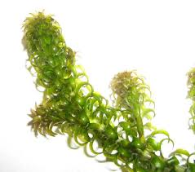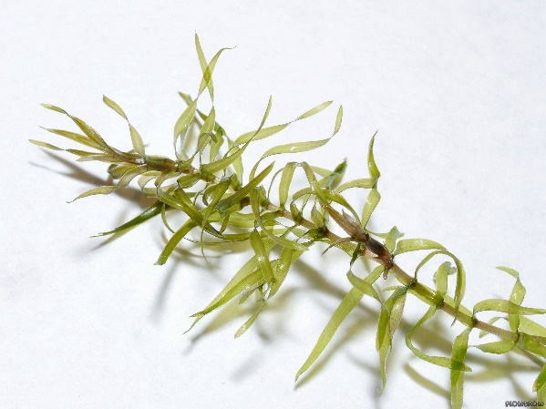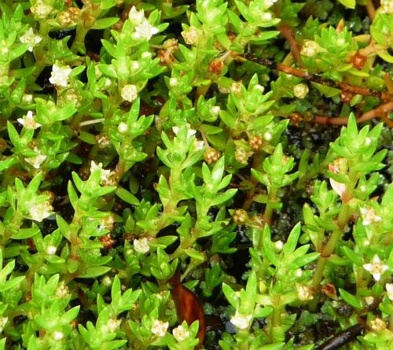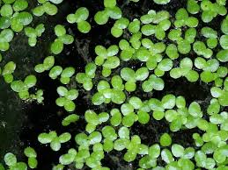

**Left to right: Curly Waterweed (*Lagarosiphon major*), Least Duckweed (*Lemna minuta*), New Zealand Pigmyweed (*Crassula helmsii*), Nuttall’s Waterweed (*Elodea nuttallii*).**

**Further reading**

[Managing recently created grassland (CIEEM)](https://cieem.net/wp-content/uploads/2019/07/Managing-recently-created-grassland-Flora-locale-technical-advisory-note.pdf)

[Grazing for biodiverse grassland (CIEEM)](https://cieem.net/wp-content/uploads/2019/07/Grazing-for-wild-plants-and-biodiversity-FL-Advisory-Note.pdf)

[Traditional cut and graze management (Plantlife)](https://meadows.plantlife.org.uk/3-maintaining-meadows/managing-a-hay-meadow/)

[Floodplain Meadows – Beauty and utility. A technical Handbook (Floodplain Meadows Partnership)](https://floodplainmeadows.org.uk/sites/default/files/files/Floodplain%20Meadows%20-%20Beauty%20and%20Utility%20A%20Technical%20Handbook.pdf)

[Technical Information Note TIN063. Sward enhancement: diversifying grassland by spreading species-rich green hay (Natural England)](https://www.lincstrust.org.uk/sites/default/files/2018-03/diversifying_grassland_by_spreading_species_rich_green_hay.pdf)

[Thistle Control in Grassland (Bedfordshire, Cambridgeshire and Northamptonshire Wildlife Trust)](http://www.magnificentmeadows.org.uk/assets/pdfs/Thistle_Control_in_GrasslandLATEST.pdf)

[Management of ponds after creation (Freshwater Habitats Trust)](https://freshwaterhabitats.b-cdn.net/app/uploads/2022/11/managing-ponds-after-creation.pdf)

**Table 4. Summary of management measures.**

| Habitat area | Objective | Management measure | Frequency and timing | Responsible party | Review |
| --- | --- | --- | --- | --- | --- |
| **Grassland restoration area** | Maintain floodplain grassland restoration area as species-rich hay meadow. | Traditional management as hay meadow - annual cycle of hay cut and aftermath grazing or cut and collect only management if grazing not possible. | See 0 and 0 | Landowner | Based on monitoring results and availability of cutting. |
| Manage weed species | Monitor and remove any weed species that grow in and around the restoration area. | Ongoing. | Landowner | The decision on weed management measures required will be informed by monitoring for these species. |
| **Floodplain wetland mosaics** | Maintain wetland mosaic features and promote increase in freshwater biodiversity in this area. | Grazing will also benefit the wetland. | Ongoing. | Landowner | Based on monitoring results and availability of cutting. |
| Manage for invasive, non-native species (INNS) | Monitor for INNS. | Ongoing. | Landowner | If monitoring reveals the presence of INNS, then a decision should be made at the time. |
| Manage water quality | All freshwater habitats created and restored should be maintained as clean water features. | Ongoing. | Landowner | Monitor any pollution incidents and act to stop them accordingly. |

**Habitat management outcomes**

**Grassland restoration area**

Promote establishment of wildflower species that were delivered via green hay application and maintain the populations of these at the site. This includes key species such Great Burnet (*Sanguisorba officinalis*), Common Knapweed (*Centaurea nigra)*, Bird’s-foot Trefoil (*Lotus corniculatus*), and Meadow Vetchling (*Lathyrus pratensis*).

Increase the number of species recorded at the site. In May 2024, 48 species were recorded, including Great Burnet (*Sanguisorba officinalis*) (see Appendix 1). With management, a good outcome would be to see this number increase from the 48 currently recorded and include more broadleaved species such as those mentioned above.

Maintain low cover of ‘weed’ species such as Creeping Thistle (*Cirsium arvense*). See sections 4.2.2 for weed management advice.

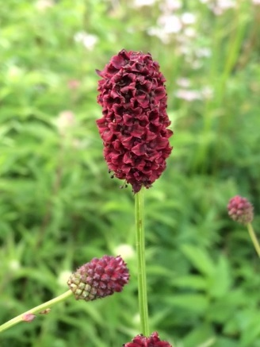

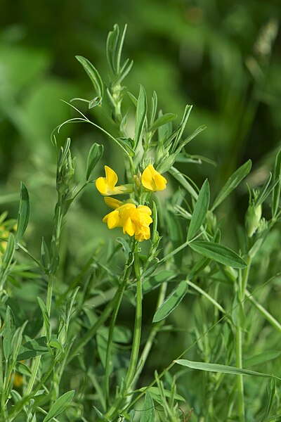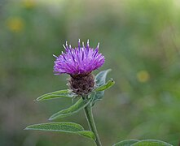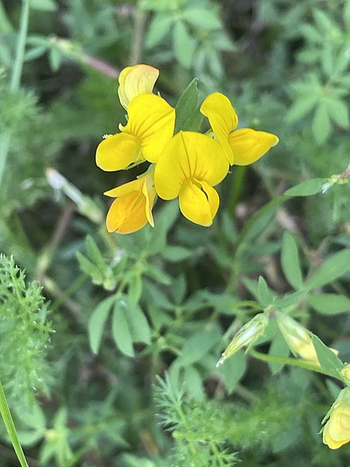

**Left to right: Great Burnet (*Sanguisorba officinalis*), Common Knapweed (*Centaurea nigra)*, Bird’s-foot Trefoil (*Lotus corniculatus*), and Meadow Vetchling (*Lathyrus pratensis*).**

**Floodplain wetland mosaics**

The desired outcome is for the site’s wetland mosaics is to support a healthy freshwater plant and animal communities.

Maintain an overall clean water status.

Provide forage habitats for waders.

**Mill Meadow grassland species pre-restoration (May 2024)**

|  |  |
| --- | --- |
| **Scientific name** | **Common name** |
| *Alopecurus pratensis* | Meadow Foxtail |
| *Anthriscus sylvestris* | Cow Parsley |
| *Arrhenatherum elatius* | False Oat-grass |
| *Barbarea vulgaris* | Wintercress |
| *Carex hirta* | Hairy Sedge |
| *Centaurea nigra* | Common Knapweed |
| *Cerastium fontanum* | Mouse-ear Chickweed |
| *Cirsium arvense* | Creeping Thistle |
| *Crataegus monogyna* | Hawthorn |
| *Dactylis glomerata* | Cock's Foot |
| *Deschampsia cespitosa* | Tufted Hairgrass |
| *Epilobium hirsutum* | Great Willowherb |
| *Epilobium parviflorum* | Hoary Willowherb |
| *Festuca rubra* | Red Fescue |
| *Ficaria verna* | Lesser Celandine |
| *Filipendula ulmaria* | Meadowsweet |
| *Galium aparine* | Cleavers |
| *Galium verum* | Lady’s Bedstraw |
| *Geranium dissectum* | Cut-leaved Crane's-bill |
| *Heracleum sphondylium* | Common Hogweed |
| *Holcus lanatus* | Yorkshire Fog |
| *Jacobaea erucifolia* | Hoary Ragwort |
| *Jacobaea vulgaris* | Common Ragwort |
| *Lathyrus pratensis* | Meadow Vetchling |
| *Lolium perenne* | Perennial Ryegrass |
| *Persicaria amphibia* | Amphibious Bistort |
| *Plantago lanceolata* | Ribwort Plantain |
| *Poa pratensis* | Smooth Meadow-grass |
| *Poa trivialis* | Rough Meadow-grass |
| *Potentilla reptans* | Creeping Cinquefoil |
| *Ranunculus acris* | Meadow Buttercup |
| *Ranunculus bulbosus* | Bulbous Buttercup |
| *Ranunculus repens* | Creeping Buttercup |
| *Rosa canina* | Dog-rose |
| *Rosa rubiginosa* | Sweet Briar |
| *Rosa sp.* | A Rose |
| *Rumex acetosa* | Common Sorrel |
| *Rumex crispus* | Curled Dock |
| *Rumex obtusifolius* | Broad-leaved Dock |
| *Sanguisorba officinalis* | Great Burnet |
| **Scientific name** | **Common name** |
| *Schedonorus arundinaceus* | Tall Fescue |
| *Symphytum officinale* | Common Comfrey |
| *Taraxacum sp.* | A Dandelion |
| *Trifolium pratense* | Red Clover |
| *Urtica dioica* | Common Nettle |

**Vegetation and carbon analysis sample locations surveyed by Natural England**

|  |  |  |  |
| --- | --- | --- | --- |
| Site | Plot | Latitude | Longitude |
| Mill Meadow | FHT_MM_P1 | 51.77936 | -1.47808 |
| FHT_MM_P2 | 51.77896 | -1.47837 |
| FHT_MM_P3 | 51.77838 | -1.47871 |
| FHT_MM_P4 | 51.77814 | -1.47994 |
| FHT_MM_P5 | 51.77687 | -1.47876 |
| Snipe Meadow | FHT_SM_P1 | 51.77288 | -1.47885 |
| FHT_SM_P2 | 51.77286 | -1.48025 |
| FHT_SM_P3 | 51.77322 | -1.48033 |
| FHT_SM_P4 | 51.77365 | -1.47984 |
| FHT_SM_P5 | 51.77403 | -1.47875 |

In red, plots where soil sampling wasn’t possible due to flooding.

# References

[Rothero, E., Lake, S. and Gowing, D. (eds) (2016). Floodplain Meadows – Beauty and Utility. A Technical Handbook. Milton Keynes, Floodplain Meadows Partnership](https://floodplainmeadows.org.uk/sites/default/files/files/Floodplain%20Meadows%20-%20Beauty%20and%20Utility%20A%20Technical%20Handbook.pdf)

[Technical Information Note TIN063. Sward enhancement: diversifying grassland by spreading species-rich green hay. Natural England.](https://www.lincstrust.org.uk/sites/default/files/2018-03/diversifying_grassland_by_spreading_species_rich_green_hay.pdf)

[Thistle Control in Grassland. Bedfordshire, Cambridgeshire and Northamptonshire Wildlife Trust.](http://www.magnificentmeadows.org.uk/assets/pdfs/Thistle_Control_in_GrasslandLATEST.pdf)

